CALL FOR SUBMISSIONS:
Community engagement for inclusive rural transformation and gender equality
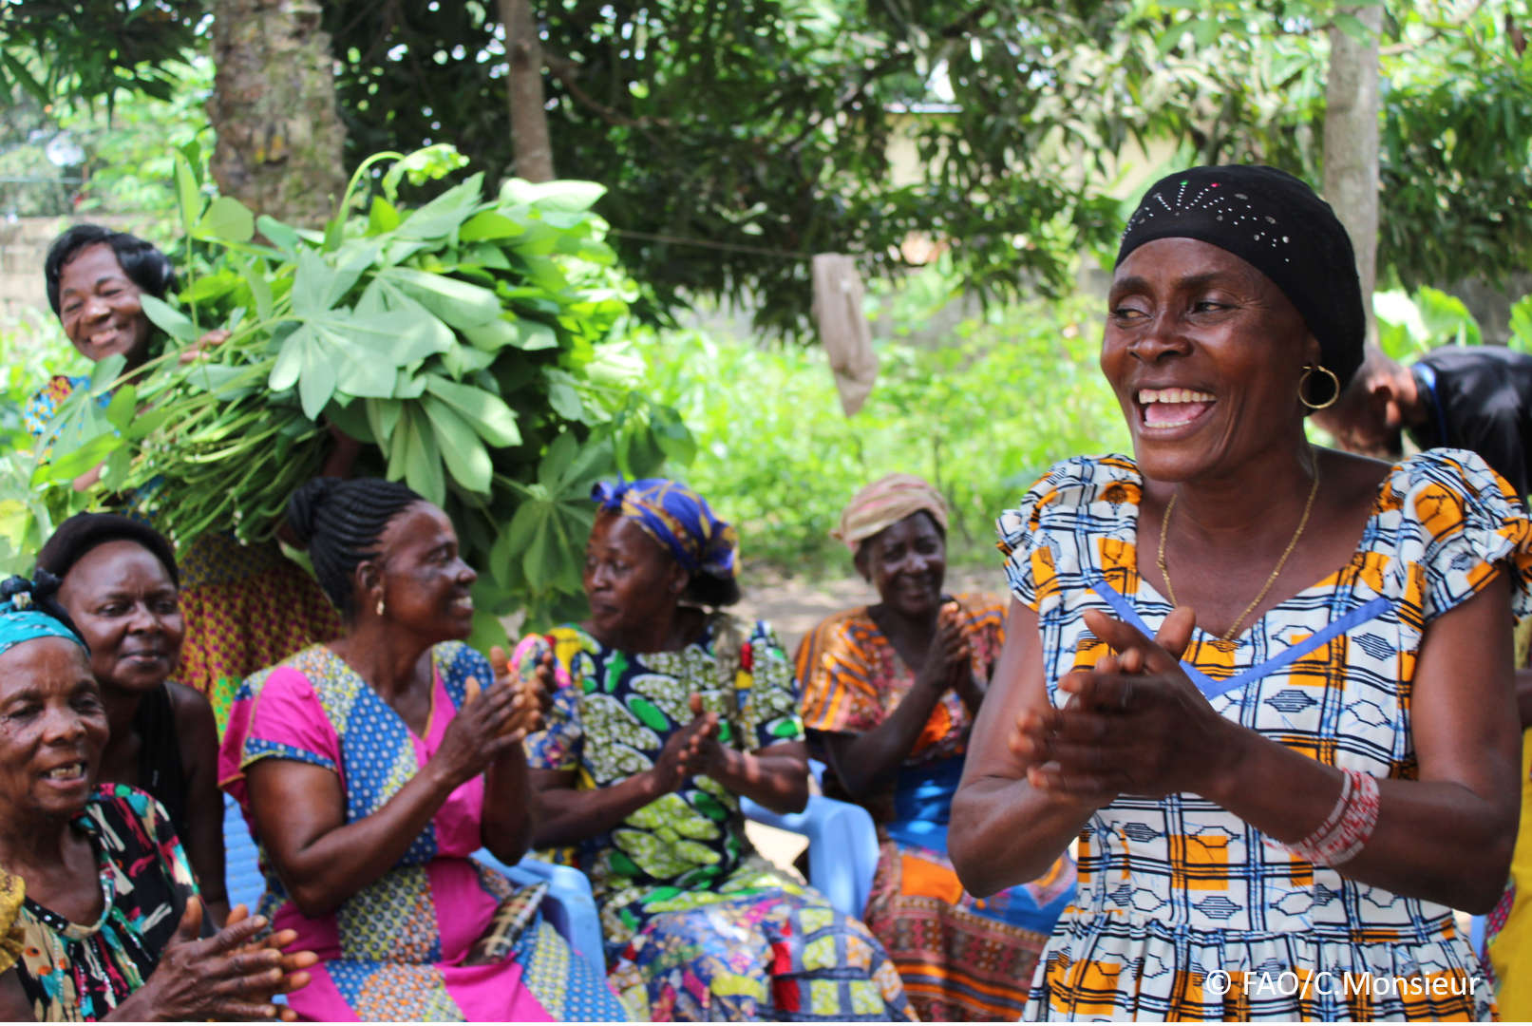
The objective of this call for submissions is to collect good practices, experiences, and lessons learnt on the use of community engagement for inclusive rural transformation and gender equality. The initiative, organized by the Rural Transformation and Gender Equality Division (ESP), seeks to gather insights from a diverse range of contributors, both within FAO and from external stakeholders. Its goal is to share knowledge, foster learning, and guide the scaling up of community engagement and community-led collective action to leave no one behind. The call builds on FAO's past efforts in this area, such as the Community Engagement Days series of webinars.
The call for submissions is open until 27 November 2024.

How to take part in this call for submissions:
To take part in this Call for submissions, please register to the FSN Forum, if you are not yet a member, or “sign in” to your account. Please review the topic note to understand the criteria we are considering for this call. If you wish to learn more about community engagement, you may refer to the background document. Once you have completed this submission template, upload it in the box “Post your contribution” on the call webpage, or, alternatively, send it to fsn-moderator@fao.org.
Please keep the length of submissions limited to 1,500 words and feel also free to attach relevant supporting materials.

Template for submissions

Contact person | Name: Fadziso Fadzisai Mawunganidze  Organization/Unit: Environmental Management Agency, Project Management Unit  Country: Zimbabwe  Email address: fadziso.mawunganidze@ema.co.zw  lloyd_muponda@wvi.org
Name/title of the good practice | Gender responsive Sustainable Forest Management- A case of Chivi, Zimbabwe
Where is the good practice taking place? (Multiple selection allowed) | ☐ Europe and Central Asia  ☐ Latin America and the Caribbean  ☐ North Africa and Near East  ☒ Sub-Saharan Africa  ☐ Asia and the Pacific  ☐ North America  ☐ Global
Affiliation | ☒ Farmer and producer organizations  ☐ Trade Union  ☐ Informal community-based, farmer-based or self-help group  ☐ Research and academia  ☐ Government  ☐ Local/traditional authorities  ☐ Private Sector  ☐ Civil Society Organization  ☐ Intergovernmental Organization (e.g. UN system, World Bank)  ☐ Resource Partner/Donor  ☐ Other (please specify)
In which sector(s) and context (s) have you used this community engagement good practice? (Multiple selections allowed) | ☐ Education  ☐ Health and Sanitation  ☒ Food production in agrifood systems (please also tick the sub-categories)  ☒ Crop cultivation  ☐ Fisheries and aquaculture production  ☐ Livestock  ☒ Forestry  ☒ Agroforestry  ☐ Horticulture  ☐ Apiculture (beekeeping)  ☒ Agroecology and sustainable farming practices  ☐ Soil and water management  ☐ Other: ____________  ☐ Post-production in agrifood systems (please also tick the sub-categories)  ☒ Processing and value addition  ☐ Marketing and retailing  ☐ Transporting  ☐ Food loss and waste  ☐ Packaging  ☐ Storage  ☐ Distribution  ☐ Other _________  ☒ Gender Equality  ☒ Climate Action  ☐ Citizenship and Governance  ☒ Social Protection  ☐ Humanitarian and protracted crisis  ☐ Conflict resolution, peace and resilience  ☐ Digital innovation  ☐ Other sector (please specify) _________
Who are the financial partners supporting this good practice, if applicable? | DSLIP- Zimbabwe funded by the Global Environment Facility (GEF) through FAO as the GEF accredited Agency.
- In a few sentences, summarize your community engagement good practice.

The Marula Zimbabwe cooperative in Ward 16 of Chivi, Zimbabwe is a group of 87 people (69 women, 6 men, 7 young women, and 4 women with disability) who are mainly into harvesting and processing of marula to produce marula oil, butter, cake, and nuts. The engagement good practice focuses on nesting community members, particularly women in dryland value chains and niche markets through business group models and economic empowerment for rural development, climate resilience and sustainable management of production systems. The cooperative has been an agent of transformation in communities as it helps to properly integrate the community members particularly women in the marula value chain with improved access to profitable markets for diversifying income sources. Other activities have been promoting adoption of innovation and sustainable practices in farming systems by capacitating women as front-line change agents in responding to land degradation and climate change related shocks.
- What problem(s) or challenge(s) does your good practice aim to address through community engagement?
The practice aims to address decline in agriculture productivity (due to land degradation and climate change induced crop failure) that puts pressure of land and forest with increasing risk the livelihoods of rural women and other vulnerable groups. Such groups are resorting to Non-Timber Forest Products (NTFPs) like the Malura as safety net and better livelihood option than cutting down trees that leads to further deforestation. Yet, there has been limited options for value-adding activities and access to market. In addition, unstainable practices continue increase threats of crop failure. The group works together with their local community leaders and government authorities for holistic solution by promoting sustainable agriculture practices (to reduce crop failure) combined with the diversification of income sources from the harvesting, value addition and marketing of Marula and other NTFPs. Through this practice, the group and their communities receive support services from their financial partners in the form of technical assistance, on business development (business planning, access to markets, technology and financial inclusion) in marula processing and marketing.
In the community, land ownership is traditionally held by men and as such women often lack the collateral needed to secure loans or investments in agriculture and business activities. This community engagement practice is therefore supporting the group with processing equipment to enhance value addition and reduce time, and labour on manual processing, linking the groups to viable markets, and partners as well building their capacity on business management through training, establishment of Village Savings and Lending Schemes, ISALS etc.

The entire community is affected by impact of land and forest degradation as well as climate change induced drought. Through other activities of the DSLIP, the group is also capacitated on catchment management, sustainable crop production (sustainable intensification) and forest management through tree planting and Assisted Natural Regeneration (ANR) to build their resilience.
- Describe your good practice in more detail. Include the main guiding principles, the desired changes or outcomes you aim to achieve (Theory of Change), and the key phases of implementation.
Land degradation is prevalent in Chivi and because of low rainfall the mopane miombo woodlands provide a safety net for survival. Land degradation has greater impacts on women and the disadvantaged as they have limited livelihood options and gather most of the resources they need for day to day survival from the environment eg wood fuel, water and food. Capacitating women therefore to run viable businesses and diversifying their food and income sources cushions them from climate shocks. A key principle in achieving this objective is the need to ensure ecosystem resilience and sustainable management of the forest resources they rely on so that there is sustainability. Social cohesion is also another key need to enhance women negotiating power and knowledge sharing among themselves. Compared to individual community members, the group provides the social capital – tested collective actions, knowledge and experience in knowledge exchange that help to mobilize the community people for learning and exchange that facilitates the adoption of innovative techniques and sustainable farming practices more rapidly among the entire. Moreover, the group provides structured institutional platform that host and manage the processing equipment to extend its support services to both their members and the community at large, even beyond the project timeframe.
Desired changes expected from the intervention include improved land and forest status, improved livelihoods of women and other vulnerable groups as well as knowledge sharing with other groups. The intervention is gender responsive and seeks to improve women participation in decision-making processes and inclusivity.

Support of the cooperative started with a Capacity Needs Assessment of the group to identify strengths, weaknesses and opportunities for support and upscaling. This informed the development of the FFS strategy and action plan, Integrated Capacity Development Plan as well as a robust training programme which included training on governance, Land Degradation Neutrality, sustainable intensification, sustainable forest management, Internal Savings and Lending (ISALs), business planning, business development as well as gender and social inclusion which was mainly targeting the gender champions. Engagement sessions were also facilitated between the group and private sector players, funding institutions, input and output markets as well as groups involved in similar interventions. The next phase which is continuous throughout the life of the project is monitoring of community activities towards the achievement of set outcomes, business incubation, and support of the group with processing equipment, market linkages etc. Other ongoing activities include gender sessions aimed at engaging women to ensure they have access to information and support.

- Who are the key actors and stakeholders involved in the design and implementation of the good practice, and what are their respective roles? Consider local partners, government, local authorities, community radios, civil society, research, the private sector, etc.
The good practise is supported by the local leadership such as the traditional leaders (chiefs and village heads). The leaders are supporting with mobilisation of communities to participate in the meetings and trainings. The leaders have been sensitised on the project and are also raising awareness on the importance of land restoration for improved livelihoods.

The project interventions are aligned and integrated into existing programmes and structures to ensure sustainability and outscaling. Marula Zimbabwe is also being supported by Ministry of Local Government departments at the district and ward level; Ministry of Women Affairs, Community, Small and Medium Enterprises Development; Agritex Extension Officers and Forestry Commission. Community Technology Development Trust, one of the projects Implementing Partners is also working with Agritex extension officers to support the community group on sustainable crop production. The private sector is also involved in business incubation as well as markets related issues. Success stories of the project are flighted on various media platforms ranging from social media, print and electronic media and lessons learnt from other interventions by civil society are shared.
The community group consists of a committee as well as a gender champion trained to oversee gender related issues in the FFPO work.
- How does your intervention ensure inclusivity and equal and meaningful participation within the community?
Describe how your intervention includes and engages different groups within the community. Consider aspects like gender, age, ethnicity, disability status, livelihoods, and other specific conditions (e.g., people living in prolonged crisis, migrants, refugees). Explain how your intervention engages diverse segments of the rural community. Highlight the specific actions or strategies you use to reach these groups. If applicable, mention if your intervention uses specific approaches such as gender-responsive, gender-transformative, intersectionality, or other methods to ensure inclusivity and gender equality.
From the onset, the project prioritized gender mainstreaming as a core objective into every aspect of the project’s initiative, as is captured in a Gender Action Plan. Comprehensive capacity building and training for both beneficiaries and project staff were crucial for the successful mainstreaming of gender. This training not only enhanced the skills and knowledge of participants but also raised awareness about the importance of gender equality in achieving Land Degradation Neutrality. The trainings also improved gender and inclusion; ensuring that women, youth, and marginalized groups actively participate and benefit. The sessions with Marula Zimbabwe also improved social cohesion as the farmers work together and indigenous knowledge is leveraged through this process.

Building the capacity of community leaders, all relevant stakeholders, gender champions and project staff on gender ensures integration all the way. The active involvement of officers from the Ministry of Women Affairs across all levels has also been instrumental in ensuring gender considerations are met in implementing activities with the cooperative. A factsheet on Gender and Land degradation was developed and shared with stakeholders.
A gender strategy, and checklist were developed and are being used to guide all project activities and ensure inclusion. Gender dialogues and well as gender analysis throughout the life of the project provides checks and balances to ensure inclusion. The gender checklist for instance guides on appropriate venues, times and approaches to ensure fair participation in meetings and activities by everyone. The inclusion of such activities as ISALS promotes active involvement of women in the project.
- By using community engagement, what results and impacts have your good practice achieved?
Please provide specific examples and evidence demonstrating the effectiveness of your intervention, focusing on both qualitative and quantitative outcomes related to livelihoods and

DSLIP support to Marula Zimbabwe is at its infancy and major areas of focus so far have been training on business development and linking the group to stakeholders including the private sector. This work has seen an improvement in markets, market bargaining and hence income for the FFPO. A 50-100% increase in price per kg of marula has been recorded.

Another impact has been the strengthened capacity of women and youths who are now actively participating in decision-making, ensuring interventions align with their needs and priorities. Women’s participation within value chain and agricultural structures have been supported ensuring that their voices are heard in decision-making processes. Currently, 4 group members have been trained on VSL and gender and the members have recruited at least 40 members to be part of VSL. This has improved women’s participation in decision making processes and leading sessions on VSL and gender.

Gender training and engagements have resulted in men sharing household responsibilities and recognizing women’s economic contributions. Testimonies from the group are that men are now supporting women with gathering and collecting marula fruit, in some cases for elderly women who are no longer able to participate in the processing, the husbands and children are involved. This however needs to be monitored to ensure continuity.
To enhance SFM, and farmer management natural regeneration, the project members are practicing agroforestry and planting marula in their fields as well as supporting the regeneration of trees in the forest.
- Among these results, has the good practice led to improvements in terms of gender equality, women’s empowerment, and/or social inclusion?
Describe the behavioral changes in terms of gender that the good practice promotes, emphasizing agency, leadership, and participation in local governance. Include efforts to challenge discriminatory norms and unequal power dynamics. Highlight also how the intervention has supported the well-being (including psychological resilience) of marginalized groups and enhanced their inclusion and participation in decision-making processes.

The community dialogues that are being conducted with Marula Zimbabwe focus on challenging harmful stereotypes, engaging men and boys as allies to support gender equality and addressing unequal power relations that limit women’s participation.

Enhanced social inclusion due to interventions focusing on building supportive networks and promoting a sense of belonging especially for the youths within the Marula Zimbabwe Cooperative has been seen. A safe-space has been created to support women, youths including survivors of gender-based violence, enhance their self-esteem and provide peer support.

The focus on NTFPs has been a gender-responsive value chain approach as its economic empowerment for the women and girls in the community who has the routine of NTFP harvesting and sale. Today, they are able to add value and tap into more rewarding for Marula market.

Enhanced inclusion in decision-making processes as more women from Marula Zimbabwe occupied influential roles in decision-making bodies such as chairpersons and treasurer. The community-based value chain project is ensuring that the women-led business has a say in pricing decisions and market access strategies.
- What key challenges did you encounter while implementing the community engagement activities, and how did you address them?
Include any resistance from communities, pushback, or issues related to unequal power dynamics, if applicable.
The group has males who work behind the scenes that at times the women end up doubting their capacity to deliver their leadership within the cooperative. The project is supporting inclusive dialogues and awareness-raising activities that involve men, community leaders, and influential stakeholders. The intervention is building broader support for women and male champions are also being identified to promote the message on gender equality and women empowerment.
- What are the key lesson learned from your community engagement good practice?

Building the skills, knowledge, and confidence of marginalized groups especially women enabled women and other marginalised groups from Marula Zimbabwe to participate in decision-making and leadership to some extent.
Empowering communities to identify their priorities and co-design solutions strengthens ownership of the project. For example, the community action plans and business plans from Marula Zimbabwe assisted those muted voices to participate and make decisions on issues that affect them in the drylands. The participatory decision-making processes also allows communities to take the lead, ensuring interventions align with their realities and needs.
Ensuring meaningful participation of all community members particularly women, marginalized groups, and youth strengthens ownership of the community practice. Marula Zimbabwe worked to overcome barriers that hinder women’s participation such as providing flexible schedules, safe spaces, and inclusive platforms that allow underrepresented voices to participate in community engagements.
- Has this practice been replicated in the same context or in different contexts?
What are the required conditions to replicate and adapt the practice in another context/geographical area?
The practice, particularly the project support extended to Marula Zimbabwe is being replicated in other FFPOs in the project area.
- How sustainable are the results achieved by this good practice?
Describe the key elements that need to be in place to make the initiative sustainable, including enabling environment (legal and policy frameworks and institutions), local ownership, accountability, etc.

Legal and policy frameworks and institutions should be in place to make the initiative sustainable. For example, engagements are in progress to support the sustainable extraction/management of NTFPS under the project.

There is also need to strengthen partnerships with local governments, institutions, and civil society organizations to align Marula Zimbabwe initiatives with broader development priorities. The cooperative will be recognised and also supported by the government departments and other civil society organisations during and beyond the project.

The cooperative has to take full ownership of the DSL-IP initiatives, with the local leadership and community-based organisations driving the process. The local ownership also consists of community driven solutions and monitoring results. Capacity building is a continuous process and this will be done through the life of the project and beyond the project cycle.
- Based on the conversations FAO held during the Community Engagement days, a definition of community engagement for empowerment was proposed:

“Community engagement for empowerment and community-led collective action can be defined as an inclusive and participatory process that enables community members to become active agents of change in decisions affecting their lives, health, and environment. This process develops their capacity to achieve sustainable outcomes for improved rural livelihoods. Embracing a rights-based approach, it prioritizes the agency and participation of all community members, regardless of gender identity, sexual orientation, age, ethnicity, caste, socioeconomic status, political affiliation, migration status, or ability/disability. Indeed, inclusive approaches recognize the complexities of overlapping marginalization and discrimination that can exclude different community members from decision-making processes and implement strategies to foster their participation, agency and empowerment.”

We invite you to contribute to this definition. What would you add or change? Please share your thoughts, suggestions, and any additional elements you believe are crucial for a comprehensive understanding of community engagement approaches aimed at community-led collective action for inclusive rural transformation, people’s empowerment and gender equality.

We will add these words intersectionality, power to, action

- Based on your experience, what gaps or areas for improvement still need to be addressed in the field of community engagement?
Limited financial and human resources, poor infrastructure, and lack of access to modern technology hinder meaningful community engagement, especially in rural communities. Projects need to be innovative for example supporting low-cost solutions such as mobile technology, or community-based resource sharing through village savings lending schemes.
Social and cultural norms hinder meaningful participation of vulnerable and marginalised groups. Changing deeply rooted discriminatory social and cultural norms takes time and lacks sustained, multi-level efforts. Projects needs to design holistic approaches that address norms at levels such as individual, household, community, and institutiona over a long period to monitor and capture changes. Furthermore, male engagement and partnering with community leaders as allies and role models also helps in driving systemic change in the communities.
Projects that are implemented in the communities are on short-term basis and mostly they are project-based, resulting in a lack of continuity and lack of sustainability after support from project funders or implementing partners. To improve on that projects has to focus more on sustainability strategies such as institutionalization of community-driven governance, development of local leadership, and integration of interventions into existing policies and systems. Therefore, building long-term local capacity and ownership is critical for sustainability of good practices from the project’s interventions.
- What do you think is FAO's role in the field of community engagement? How can FAO support and enhance interventions like yours, if applicable? Consider aspects such as policy advocacy, capacity development, funding, technical assistance, knowledge production and sharing, and fostering partnerships.
FAO can support the practice with capacity development funding, knowledge production and sharing and fostering partnerships.

Link(s) to specific references about your good practice (e.g. reports, communication products, videos, articles) | Please include attachment(s) or add here link(s) to documents/videos/podcasts/other with specific references.  https://drive.google.com/drive/u/0/mobile/folders/1-A-seel7zCVw-DefyUHzk2G19tp-cuy7?usp=drive_link

The call for submissions is directly aligned with the thematic components of collective action within FAO's Programme Priority Areas (PPAs), specifically Better Life 1 (Gender Equality and Rural Women’s Empowerment), Better Life 2 (Inclusive Rural Transformation) and Better Life 3 (Agriculture and Food Emergencies).

